Loan Default Prediction Report
This report outlines the process of exploring, building, and evaluating a machine learning model to predict loan default risk. The objective is to identify high-risk borrowers and provide actionable insights to support better credit decision-making.

Data Identification and Collection
The dataset consists of applicant-level financial and credit information. The key components include:
- Demographics: Age, home ownership status, employment length
- Financial Information: Income, loan amount, loan percent of income
- Credit History: Credit history length, previous defaults
- Loan Details: Loan intent, loan grade, interest rate
- Target Variable: Loan status (Default = 1, Non-default = 0)

Exploratory Data Analysis
Exploratory data analysis was conducted to understand borrower behaviour and identify patterns associated with default risk.
Key findings include:
- Borrowers with higher loan-to-income ratios are more likely to default
- Lower income is associated with higher default risk
- Larger loan amounts show increased likelihood of default
- Renters and certain loan intents (medical, debt consolidation) have higher default rates
- Most numerical features are right-skewed, with notable outliers

Figures
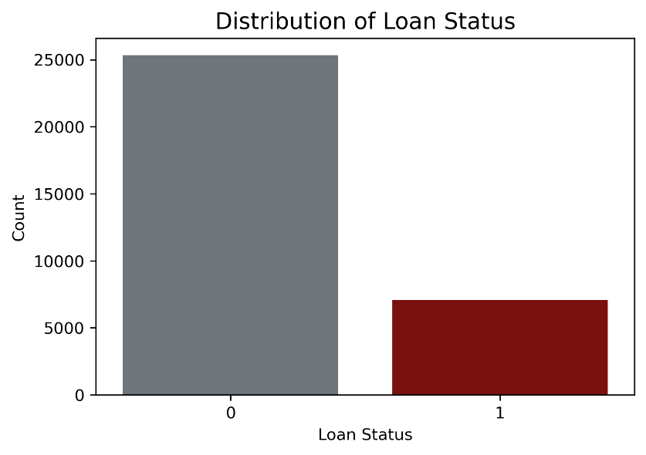
Figure 1: Distribution of Loan Status
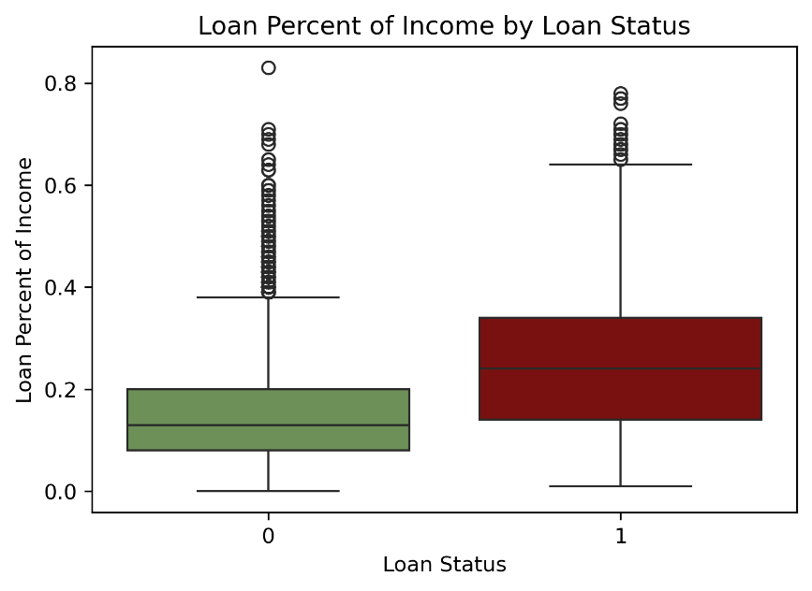
Figure 2: Loan Percent of Income vs Loan S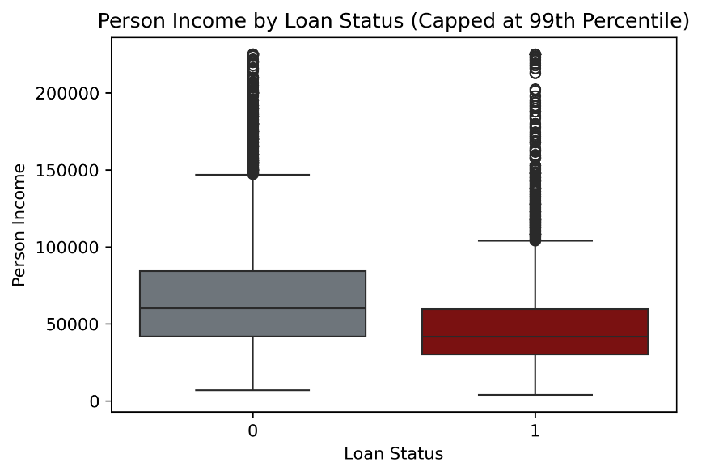
Figure 3: Person Income vs Loan Status

Model Selection and Building
A Logistic Regression model was selected due to its interpretability and suitability for binary classification problems.
The modelling process included:
- Data cleaning (handling missing values and duplicates)
- Encoding categorical variables
- Standardising numerical features
- Splitting data into training and testing sets (80/20 with stratification)

Model Evaluation
The model was evaluated using classification metrics including precision, recall, F1-score, and confusion matrix.
- Baseline Model Accuracy: ~87%
- Strong performance in identifying non-default cases
- Initial recall for default detection: 0.57
To improve performance:
- Class weighting was applied but showed no improvement
- Threshold tuning (0.50 → 0.30) significantly improved results
After threshold adjustment:
- Recall for default cases improved to 0.72
- False negatives were reduced
- Slight decrease in overall accuracy and precision

Recommendations and Business Implications
The model provides valuable insights for credit risk management:
- Focus on affordability: Loan-to-income ratio is a key risk driver
- Target high-risk segments: Renters and specific loan purposes
- Adjust decision thresholds: Improve detection of risky borrowers
- Enhance risk strategies: Combine model predictions with policy rules
Further improvements may include:
- Advanced models such as XGBoost or Random Forest
- Additional feature engineering
- Regular model retraining with updated data

